Chapter 2

Axioms of Probability

- Introduction
- In this chapter, the following basic concepts of probability will be introduced:
    - sample space;
    - event;
    - probability of an event;
    - basic assumptions (axioms) of probability theory.

  - Sample Space and Events
- Review of terms (mentioned previously in Chapter 1) ---
    - Experiment --- any human activity.
    - Outcome --- a result of an experiment.

- Some additional terms ---
    - Sample space of an experiment ---
The sample space of an experiment is the set S of all possible outcomes of the experiment.
    - Event ---
An event is a subset E of a sample space S, which is usually a set consisting of possible outcomes of a certain meaning.

- Example 2.1 ---
In an experiment of flipping two coins in order, we want to know if a head appears on the first coin. In this case, “flipping with a head appearing on the first coin” is an event. Therefore, we have:
    - sample space S = {(H, H), (H, T), (T, H), (T, T)}, where H denotes the “head” of the coin and T the “tail”;
    - event E = {(H, H), (H, T)}.

- One more term and some notes ---
    - Occurrence of an event ---
If an outcome of an experiment is contained in an event E, then we say that event E has occurred.
    - Some comments ---
Events are sets, so all set operations and related theorems can be applied to them. Also, outcomes are elements of sets of events.

  - Axioms of Probability
- Probability of an event ---
For each event E of the sample space S, it is assumed in probability theory that a number P(E) is defined, called the probability of E, which satisfies three basic assumptions, called axioms, described later.

- Notes ---
    - The above definition of probability is based on the modern axiomatic approach to probability theory.
    - How to measure or define probability will be explained later.
    - P(·) may be regarded as a set function (i.e., a function with sets constituting its domain).

- Some terms ---
    - Mutual exclusiveness ---
Two sets are said to be mutually exclusive if their intersection is an empty set φ.
    - Axiom ---
An axiom is a statement that is considered to be self-evident and serves as a starting point for deducing and inferring other facts. No proof of it is provided.

- Three axioms of probability ---
With S being a sample space and E an event, we have the following axioms for use in probability theory:
    - Axiom 1:
0 ≤ P(E) ≤ 1.

    - Axiom 2:
P(S) = 1.

    - Axiom 3:
For any sequence of mutually exclusive events E₁, E₂, ..., the following equality holds:
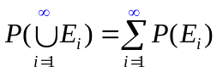.

- A note ---
Axiom 3 says that the probability of the union of all mutually exclusive events is the sum of their respective probabilities.

- Two facts deduced from the axioms ---
    - Fact 2.1:
P(φ) = 0.
Proof:
See the proof of Fact 2.2.

    - Fact 2.2:
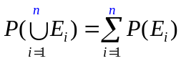.

Proof:
To prove Fact 2.1, let E₁ = S, and E_{i} = φ for all i > 1. Then, 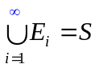, and from Axiom 3, we have
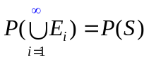=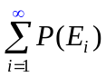=P(S) + 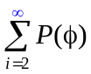,
which means that = 0, or equivalently, that P(φ) = 0 according to Axiom 1.
To prove Fact 2.2 for a finite sequence of mutually exclusive events E₁, E₂, …, E_{n}, let E_{i} = φ for all i > n. Then, by the above fact (Fact 2.1) and the fact 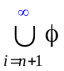 = φ, the left-hand side of Axiom 3 may be reduced to
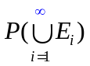=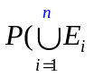+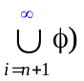= + φ) = 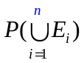. (A)
Also, using Fact 2.1 again, the right-hand side of Axiom 3 may be reduced to
=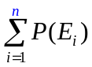+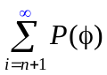 = +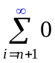=. (B)
Finally, by Axiom 3 and the above results (A) and (B), we get the result of Fact 2.2. Done.

- Notes on Axiom 3 and Fact 2.2 ---
    - When the sample space is infinite, then Axiom 3 is used; otherwise, Fact 2.2 is applied.
    - An example of infinite sample spaces is the set of all integers.

- How to define or measure a probability value ---
    - For a “basic” probability, we define it by intuition or by frequency counting.
    - For a “composite” probability, we compute it by axioms, or by derived facts or propositions from the axioms.

- Example 2.2 ---
In tossing a “fair” coin, we have:
    - sample space --- S = {H, T} where “H” and “T” mean the head and tail of the die, respectively;
    - events --- E₁ = {H}, E₂ = {T} (i.e., events of appearing to be a head and a tail, respectively); and
    - “basic” probabilities for the two events E₁ and E₂ by intuition based on the fairness assumption respectively are:
P(E₁) = 1/2, P(E₂) = 1/2.
(Note: events are sets written in the form of {·}.)

- Example 2.3 ---
In tossing a “fair” die, we have:
    - sample space --- S = {1, 2, 3, 4, 5, 6};
    - events --- {1}, {2}, ..., {6} (i.e., events with each appearing to be any of the six die sides); and
    - “basic” probability for each of the six events by intuition based on the fairness assumption is:
P({i}) = 1/6
for i = 1, 2, …, 6.

- Example 2.4 ---
What is the probability of rolling an even number with a die?
Solution:
    - The event of rolling an even number is E_{even} = {2, 4, 6}.
    - From the result of the last example and Fact 2.2, and by mutual exclusiveness of the events {2}, {4}, {6}, we get the “composite” probability of E_{even} as
P(E_{even}) = P({2, 4, 6}) = P({2}U{4}U{6})
= P({2}) + P({4}) + P({6}) (by Fact 2.2)
= 1/6 + 1/6 + 1/6
= 1/2.
(Note: the plural of die  dice.)

- How to define basic probability values by frequency counting ---
    - A classical way of defining a certain probability value is to measure it by frequency counting.
    - An example ---
To define the basic probability P(E) of the event E of tossing a coin with a head H as the outcome, the classical way is to conduct the following process:
      - repeat the tossing for n times with n being large enough;
      - find the number n₁ of times with H appearing as the outcome;
      - define the desired probability P(E) as
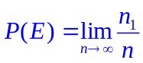.
    - Notes ---
      - The above way of defining probability values by frequency counting is intuitively sound but theoretically complicated because we have to know if the limit exits and converges or not.
      - However, it may be proved to be correct by the strong law of large number (a theorem to be proved in Chapter 7).

  - Some Simple Propositions
- Review of the set theory (I): basic operations ---
Given sets E, F, and G, and assume U as the “universal set,” the following are definitions of some basic set operations:
    - union: EUF = {x | x ∈ E or x ∈ F};
    - intersection: E∩F = {x | x ∈ E and x ∈ F};
    - subtraction: E−F = {x | x ∈ E and x ∉ F};
    - complementation: E^{C} = {x | x ∈ U and x ∉ E}.
(Note: the universal set U in the set theory is equivalent to the sample space S in the probability theory)

- Review of the set theory (II): well known laws ---
The following are some well-known laws about set operations:
    - commutative laws: EUF = FUE;
E∩F = F∩E;
    - associative laws: (EUF)UG = EU(FUG) ≡ EUFUG;
(E∩F)∩G = E∩(F∩G) ≡ E∩F∩G;
(recall: “≡” means “equals by definition”);
    - distributive laws: (EUF)∩G = (E∩G)U(F∩G);
(E∩F)UG = (EUG)∩(FUG);
    - DeMorgan’s laws: (EUF)^{C} = E^{C}∩F^{C};
(E∩F)^{C} = E^{C}UF^{C}.

- Review of the set theory (III):Venn’s diagrams ---
    - Many set operations and laws may be verified by the use of Venn’s diagrams as shown in the following.
    - In these Venn’s diagrams, the left, right, and bottom circles are sets E, F, and G, respectively; and the set operation result is the darkest portion.

(1) E∩F = 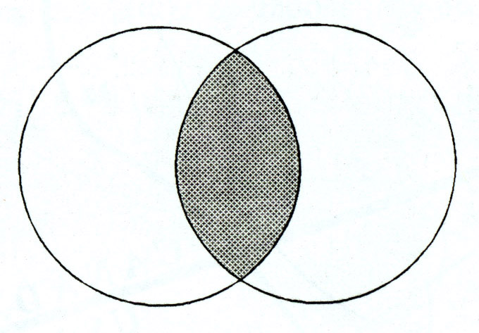. (2) EUF = 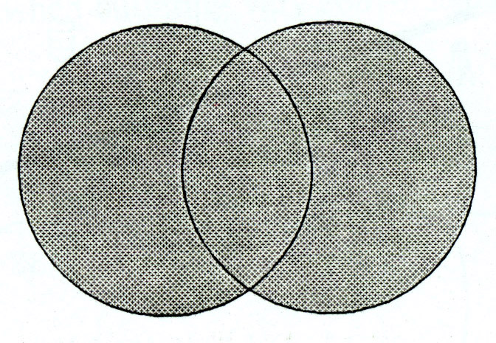.

(3) E − F = 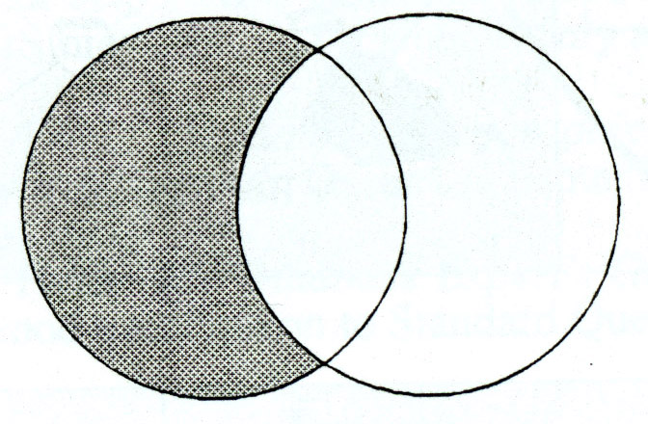. (4) E^{C} = .
(rectangular area = universal set U)

(5) E∩(FUG) = 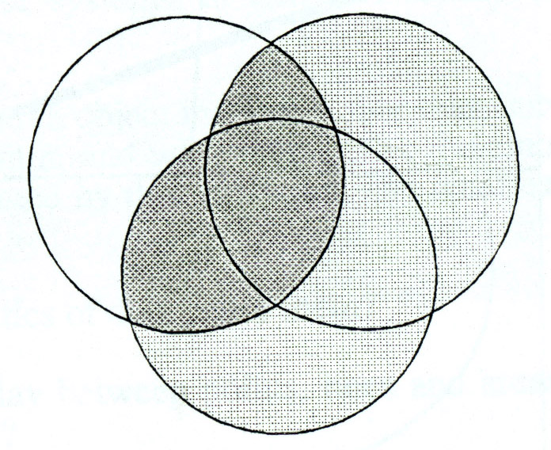. (6) (E∩F)UG = 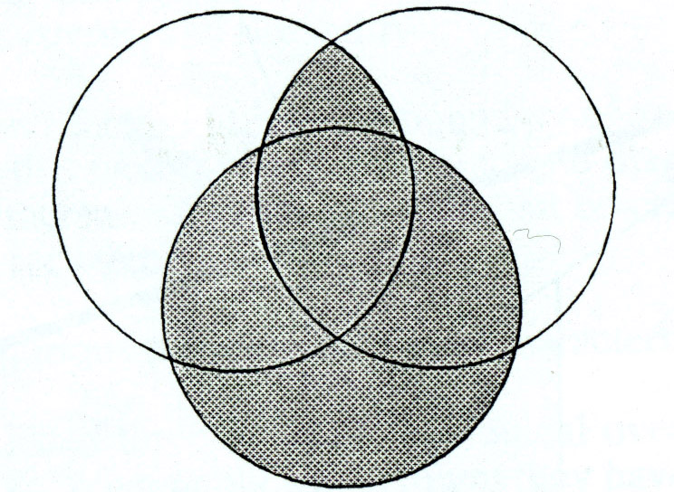.
(light gray part = FUG)

- A simplification of the notation for intersection ---
From now on, the intersection notation ∩ will be omitted unless ambiguity arises or unless emphasis is necessary. So, E∩F will be written as EF, for example.

- Explanations of some terms about derived facts:
    - A term may either be undefined (with a common-sense meaning) or defined (with a particularly assigned meaning).
    - The word “fact” is used in this course as a defined term expressing a result derived from others (note: in this sentence, for example, the word “result” is used as an undefined term).
    - “Rules,” “laws,” “propositions,” “lemmas,” “theorems,” “corollaries,” are all formal facts derived from terms, axioms, or/and other facts.
    - Lemmas and propositions usually are simpler or less “significant” than theorems, and are derived in advance for use in deriving theorems.
    - Corollaries usually are simply-derivable facts from theorems.

- Some notations and a note ---
    - In the following discussions, E, F, and E_{i} for all i = 1, 2, … denote events.
    - Recall that events are sets.

- Three propositions ---
The following three propositions are intuitively true; the proofs of them are left as exercises.
    - Proposition 2.1:
P(E^{C}) = 1 − P(E).
    - Proposition 2.2:
If E ⊂ F, then P(E) ≤ P(F).
    - Proposition 2.3:
P(EUF) = P(E) + P(F) − P(E∩F).

- Example 2.5 ---
In tossings of two fair coins one by one, what is the probability that either the first outcome or the second one is a head?
Solution 1:
The desired probability may be computed as an application of Proposition 2.3 in the following way:
    - sample space S = {(H, H), (H, T), (T, H), (T, T)} for the two tossings;
    - all events with each constituting an outcome in S are mutually exclusive;
    - each point in S has a probability of 1/4;
    - event E = {1st outcome = H} = {(H, H), (H, T)};
    - event F = {2nd outcome = H} = {(H, H), (T, H)};
    - desired event G = {1st outcome or 2nd outcome} = EUF;
    - desired probability P(G) = P(EUF) = P(E) + P(F) − P(EF) according to Proposition 2.3; (C)
    - EF = {(H, H)};
    - P(E) = P(F) = ¼ + ¼ = ½; (by Fact 2.2)
    - P(EF) = ¼;
    - so (C) above becomes P(G) = ½ + ½ − ¼ = ¾ as the final result.

Solution 2:
The above result may also be computed directly as follows:
    - G = EUF = {(H, H), (H, T), (T, H)};
    - P(G) = P(EUF) = ¼ + ¼ + ¼ = ¾. Done.

  - Sample Spaces Having Equally Likely Outcomes
- A generalization of Example 2.4 ---
Assume the following facts:
    - sample space S = {1, 2, ..., N} (with N integer values);
    - P({1}) = P({2}) = ... = P({N}) (“all outcomes are equally likely”).
Then, we have the following reasoning:
    - Axiom 2 and Fact 2.2 imply P({i}) = 1/N for i = 1, 2, ..., N (check why by yourself);
    - Fact 2.2 again implies that
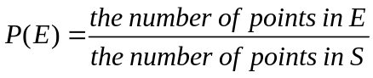
(check why by yourself again).
    - Accordingly, we have the following fact.

- Fact 2.3:
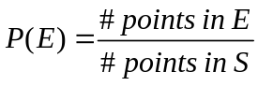
where for simplicity, we use “#” to mean “the number of.”

- Example 2.6 ---
If two balls are randomly drawn without replacement (i.e., not put back) from a bowl containing 6 white and 5 black balls, what is the probability that one of the drawn balls is white and the other black?
Solution 1:
    - Concept of solution --- regarding the order of selecting balls as significant;
    - total number of balls = 11 with 6 white and 5 black balls with them being denoted as W and B, respectively;
    - sample space S --- including 11×10 = 110 outcomes by the basic product principle of counting (note: the drawings are conducted without replacement);
    - “randomly drawn” means 110 outcomes are “equally likely to occur;”
    - event E --- “one white and one black drawn”;
    - E includes two types of mutually exclusive events:
(1) E₁ --- first white and second black;
(2) E₂ --- first black and second white;
    - so E = E₁UE₂;
    - #outcomes in E₁ = 6×5 = 30 (here, outcomes = (W₁, B₁), (W₁, B₂), …);
    - #outcomes in E₂ = 5×6 = 30 (here, outcomes = (B₁, W₁), (B₁, W₂), …);
    - the desired probability so is
P(E) = P(E₁UE₂) = [P(E₁) + P(E₂)]
(by mutual exclusiveness and Fact 2.2)
= 30/110 + 30/110 = 6/11. (by Fact 2.3)

Solution 2:
    - Concept of solution --- regarding the outcomes of the experiment as an unordered set of drawn balls;
    - sample space S --- including C(11, 2) = 55 different outcomes;
    - event E --- “one white and one black drawn”
    - E includes C(6, 1)×C(5, 1) = 6×5 = 30 possible outcomes (see Example 1.4 of Chapter 1 for the involved concept);
    - the desired probability so is
P(E) = 30/55 = 6/11. (by Fact 2.3)

  - ***Probability As a Continuous Function
(*** means “may be skipped”)

- Some terms and notations ---
    - An increasing sequence of events ---
a sequence of events {E_{n} | n ≥ 1} where E₁⊂E₂⊂...⊂ E_{n}⊂E_{n+1}⊂... (i.e., E₁ is the “smallest” set).

    - A decreasing sequence of events ---
a sequence of events {E_{n} | n ≥ 1} with E₁⊃E₂⊃...⊃E_{n}⊃E_{n+1}⊃... (i.e., E₁ is the largest set).

    - For an increasing sequence of events {E_{n} | n ≥ 1}, define 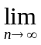E_{n} = 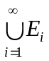, which intuitively is the “largest set at the infinitive end of the sequence.”

    - For an decreasing sequence of events {E_{n} | n ≥ 1}, define E_{n} = 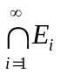, which intuitively is the “smallest set at the infinitive end of the sequence.”

- Proposition 2.4 ---
If {E_{n} | n ≥ 1} is either an increasing or decreasing sequence of events, then
P(E_{n}) = P(E_{n}).
Proof: see the reference book.

- A comment --- the above proposition means the continuity of the probability function.

  - Probability as a Measure of Belief
- Probability: relative frequency versus belief ---
    - Probability is intuitively a measure of the relative frequency of an event with respect to the total sample space of an experiment, as described previously.
    - Probability may also be regarded as a measure of one’s belief from the personal or subjective view of probability.

- Examples of probability as a measure of belief ---
    - your thought of feeling happy tomorrow;
    - the chance of meeting a certain girl in a bus this afternoon;
    - the chance of winning a horse race.

- A comment --- probability of this kind is similar to the fuzzy membership value in the fuzzy set theory.

